
Science Understanding (U) and Science Inquiry (I)

Teaching and learning that explores the intersection between Science Understanding and Science Inquiry could encourage students to apply their knowledge
of core scientific concepts to design, conduct and analyse investigations that deepen their understanding.

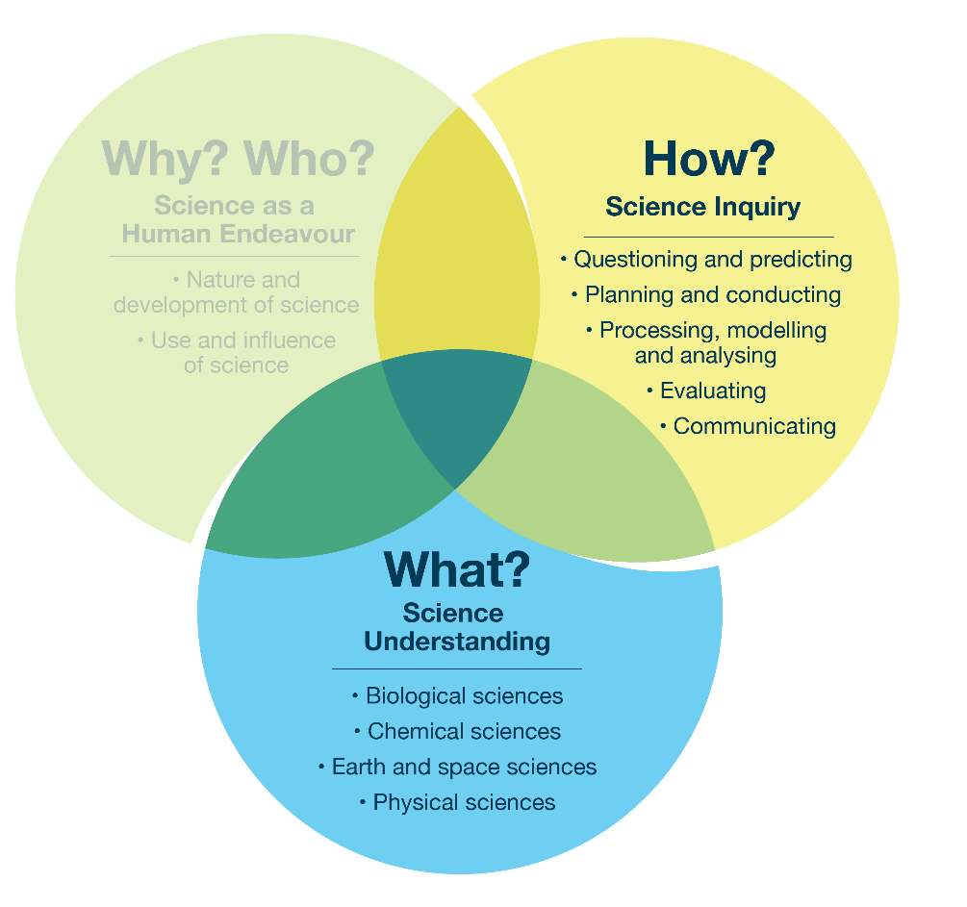
Focus 2.3 – Interconnecting Science Understanding and Science Inquiry

Example topic – multiple strands
Before creating chemical compounds like slime or oobleck, students might be prompted to draw on their knowledge of chemical reactions to make predictions and adjust quantities.
Possible focus question | Curriculum alignment
What will happen if we add more or less water to sand? | U link: Understanding how adding water changes the physical properties of sand  I link: Planning and conducting fair tests to observe how varying amounts of water change the texture and behaviour of sand  U–I overall link: Students draw on knowledge of physical changes and inquiry skills to investigate how water affects the properties of sand
Further examples on the next page.

Possible focus question | Curriculum alignment
How can we record observations about the stretchiness, texture and flow of our slime so that we can compare these observations? | U link: Understanding the physical properties of slime, including stretchiness and flow  I link: Developing methods to systematically observe, measure and record the physical characteristics of slime for comparison  U–I overall link: Students combine understanding of physical properties with inquiry techniques to collect and compare data about slime

Possible focus question | Curriculum alignment
Is oobleck a solid, a liquid or both? | U link: Understanding the properties of solids and liquids and how some materials, like oobleck, can show characteristics of both  I link: Designing and conducting tests to observe and classify the behaviours of oobleck under different conditions  U–I overall link: Students use scientific knowledge and inquiry skills to explore and explain the states of matter exhibited by oobleck

